Space Exploration: It is not just a hobby, it is a solution.
An editorial by Rodolfo Rubio
Humans have done about fifty years of space activity that has produced benefits both socially and individually that improve life quality on Earth. Every time the United States agency, the National Aeronautics and Space Administration (NASA), forms a new mission for space exploration it goes through Congress and many rigorous situations. The reason for this is because of all the arguments the majority of the public claim about spending money where it is not needed. It really makes me quite irritated because the public and politics do not do the correct research; the only reason they care is because there is government spending. However the public is not entirely wrong. NASA is really good at acquiring headlines that seem important to the cause of beneficial resources from space, but Congress began to implement new bills that state what NASA can and should do with the government budget. Committee Chair Lamar Smith thinks otherwise, he argues that it is the main interest for them to examine and explore ways to protect Earth from asteroids and meteors because it is a priority to the American people and there should also be a priority for the government. The minute the concerns of safety arose, the prospect brought up questions having to do with safety and health regulations as well as whether or not the astronauts were ready for this expedition.
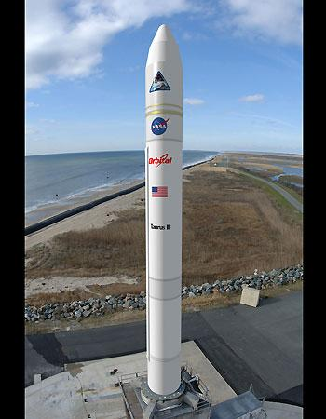
NASA’s mission statement is to discover the future in space exploration, scientific discovery, and aerospace research since February of the year 2006. Unlike space exploration in the early twentieth century, technology has advanced and is advancing to a degree that our phones can do more than the first space craft that landed on the Moon. At this point space exploration is getting easier and is costing less money, but there is yet to make politicians and the American public happy. According to NASA, exploring space is beneficial in many aspects and the main reason people argue about spending money is because they do not know that exploring space benefits the U.S. economy. For example one of NASA’s contractors for aircraft is Boeing, the company that makes commercial aircrafts for the airline industry.
As mentioned before, rigorous tasks are completed before any speculations or thoughts of reaching a goal. The benefits of a less obvious reason for space exploration are the technology derivatives that have to be created to undergo a mission. Exploring space has resulted in advancing our knowledge of human innovation and technology. For example, the artificial heart resulted from experiments on a space shuttle; the insulation in our homes was based off the technology used for the inside of the shuttle.
An alternative spacecraft, Orbital Sciences Taurus II rocket on the launch pad at the Mid-Atlantic Regional Spaceport on Virginia's Eastern Shore.
After much research, I have come up with my view on the continuation of space exploration. I always thought that exploring space was somewhat a hobby and was a fun thing we did, however I found out that it costs a lot of money, but can resolve many problems, one being the survival of mankind. A solution to the arguments of politics and the public is research or merely create new technology that is inexpensive, but can also benefit us on Earth such as NASA has done in the past. Congress passed a law that allows NASA to continue exploring space with other nations aboard the International Space Station to support American space transportation. The public has to research and continue looking for solutions to many of our problem through space exploration.

References
Griffin, M. (2007, July). The real reasons we explore space. Air & Space Magazine, p1-3. Retrieved from: http://www.airspacemag.com/space-exploration/Uncommentary.html.
Jessa, T. (2009, August 24). Benefits of space exploration. Universetoday.com. Retrieved November 25, 2013, from http://www.universetoday.com/37079/benefits-of-space-exploration/
Mead, D. (2013, June). Congress tells NASA to quit researching climate change and asteroid retrieval. Retrieved November 25, 2013, from http://motherboard.vice.com /congress-tells-nasa-to-quit-researching-climate-change-and-asteroid-retrieval
Spacecraft Alternatives. (2013). Fox News. Retrieved November 25, 2013, from http://www.foxnews.com/photoessay/0,4644,7202,00.html/#/photoessay/image/0507091140_M_cygnus_spacecraft-jpg

